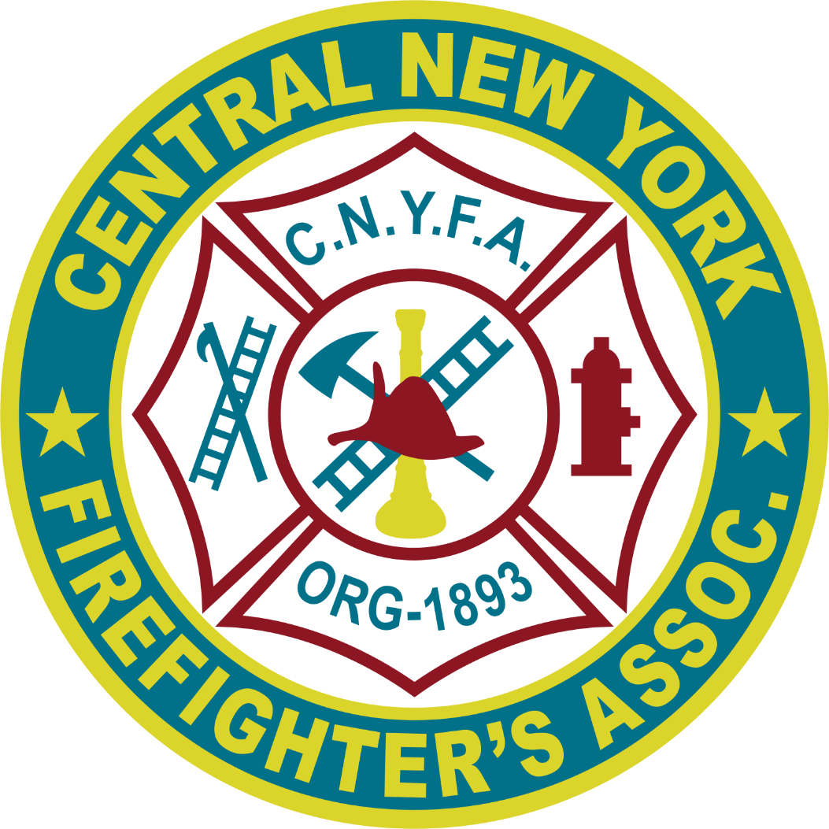
132nd CONVENTION
JULY 10 – 11, 2026
Aurelius Fire Department
6320 Half Acre Road
Auburn, New York
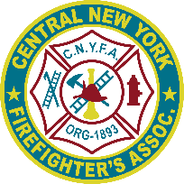
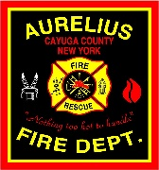

Central Members

The Aurelius Fire Department is proud to host the 132nd Central New York Firefighters Association Convention, July 10 – 11, 2026 at the Aurelius Fire Station, 6320 Half Acre Road, Auburn, NY on July 10 – 12, 2026. The information about the convention is provided to ensure that your department or organization can make adequate plans to prepare for our annual gathering and about special arrangements that have been secured to improve your participation. Please take the time to review this entire document and pass it along to your membership. Your prompt attention to these matters is vital to a successful convention. Please note specific deadlines and return the reservation form within those deadlines.

2026 Convention Time & Date – The 132nd Convention is being held Friday, July 10 and Saturday, July 11, 2026, at the Aurelius Fire Station, 6320 Half Acre Road, Auburn, NY.

Accommodations – Holiday Inn Auburn-Finger Lakes Region, 75 North Street, Auburn, New York 13021. Group CFA. Cost is $199.00 per night. 315-253-4531. You must make your own reservations. Mention you are with Central New York Firefighters Association. You must present a NYS ST-129 to be tax exempt upon check in, when paying.

Annual Dues Reminder - Corporate dues for fire departments and associations are $10 yearly. Individual dues are $5 yearly. Please contact Secretary Maryann Ouimette or Assistant Secretary Linda Rothdiener, with any questions. Dues must be paid before June 30th to be eligible to vote at the convention.

Preliminary Program Agenda - A draft program schedule is included. Any changes please forward them to any committee member.

Convention Program Book Advertisement- Please show your department’s support at the convention by placing an advertisement in this year’s convention program book. Advertisement form is provided.

Meals– Purchased Meals will be joint Luncheon on Saturday. Menus and Costs are on the reservation form. Friday Night will be the Old-Times/Newcomers free BBQ, bring a Dish or donate. Please contact Ken Holmes to bring a dish or donate.

Tournament/Hose Games– A modified games tournament will be held on Saturday, July 9, 2022, at 2 pm in the Appley Center Parking Lot.

Finally, we ask that you do not put this convention package aside but give them your earliest possible attention. The convention will be here before you know it and the Committee wants to make sure it is a most enjoyable experience for everyone. Thank you for your cooperation and assistance.

Aurelius’Fire Dept Convention Committee – Kevin Foster, Barrie Lyn Foster

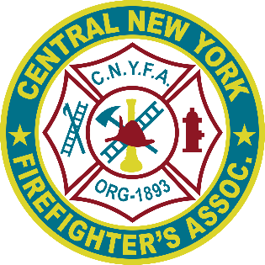
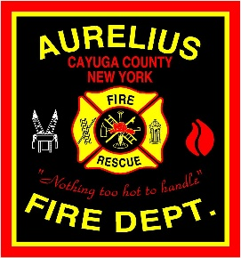
2026 CONVENTION
ACCOMMODATIONS
MAKE ON YOUR OWN
Holiday Inn Auburn-Finger Lakes Region by IHG
75 North St, Auburn, NY 13021
(315) 253-4531
https://www.ihg.com/redirect?path=rates&brandCode=HI&localeCode=en®ionCode=1&hotelCode=
SYRAU&checkInDate=10&checkInMonthYear=062026&checkOutDate=
12&checkOutMonthYear=062026&_PMID=99801505&GPC=
CFA&cn=no&adjustMonth=false&showApp=true&monthIndex=00

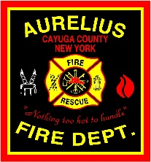
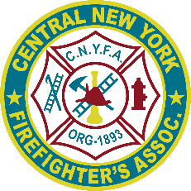
TENTATIVE PROGRAM AGENDA
132nd CONVENTION
JULY 10 – 12, 2026
AURELIUS FIRE DEPT
AUBURN, NEW YORK

FRIDAY, JULY 10
1:00 – 4:00 pm LACNYFA - E Board & Audit Meeting - (Cleveland Bldg)
3:00 - 5:00 pm LACNYFA - Registration (Cleveland Bldg)
3:00 - 5:00 pm CNYFA - Registration (Cleveland Bldg) (Maryann Ouimette & Linda Rothdiener)
5:00 – until!! OLD TIMERS/NEWCOMERS BBQ (Cleveland Bldg) (Ken Holmes)

SATURDAY, JULY 11
8:00 - 8:45 am Registration Opens CNYFA – (Appley Bldg) (Maryann Ouimette & Linda Rothdiener)
8:45 am Welcome (President Paul Rieben)
Presentation of Colors (Sgt @ Arms Larry Rieben)
Pledge of Allegiance (Assistant Sgt @ Arms Art Gage)
Nation Anthem
Invocation (Rev Elliott Oakes)
Introduction of CNYFA Current Officers, Past Presidents & Life Members
(Vice President Tom Dwyer)
Introduction of CNYFA Ladies Auxiliary President Cari Kessler (President Paul Rieben)
(Auxiliary President Cari will introduce her officers and quest to the Ladies Convention)
Introduction of dignitaries (Vice President Pat Gavin)
9:00 – 10:00 am Joint Memorial Service (Rev Elliott Oakes)
10:00 – 10:30 am Awards Program (Past President Rick Waite)
Firefighter of the Year (Past President Rick Waite)
Civilian of the Year (Past President Rick Waite)
Charles Marsfelder Explorer of the Year (Jeff Geer & Steve Kay)
Ray Sherburne-John Haley Lifetime Contribution Award (Past Presidents)
Scholarships (Vice President Pat Gavin)
RECESS (Ladies staying downstairs – CNYFA upstairs)
10:55 - 12:00pm CNYFA General Meeting (President Paul)
Officers & Committee Reports (Secretary Maryann)
Audit Report (Mike Caron)
Bylaws Report (Rebecca Franklin-Guild)
12:00 - 1:00 pm Joint Luncheon – (Appley Center) (Tom Rothdiener)
129th CNYFA Convention – (Doug Van Etten)
1:00 - 2:00 pm Reconvene to complete CNYFA & LACNYFA business
Adjournment of 128th CNYFA Convention (President Paul)
2:00 - 5:00 pm Tournaments/Gaming (Appley Center Parking Lot) (Wayne Sherwood)

as of: 10/23/2021

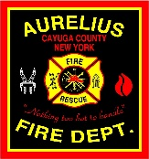
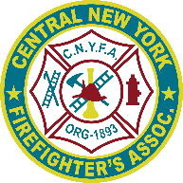
2026 CNYFA CONVENTION RESERVATION FORM

Name: ___________________________________________________________________________
Address: ________________________________City:_______________State: _______Zip: _______
Phone: ( ) ____________________________Email:_____________________________________
Current Office/Position/Title with CNYFA: _______________________________________________
ACCOMMODATIONS: Friday 7/10 ( ) Saturday 7/11 ( )
MAKE ON YOUR OWN
Holiday Inn ( ) Other____________________ ( )

OLDTIMERS NEWCOMERS BBQ: Friday 7/10 ( ) 5pm at Aurelius Fire Station.
Bring a dish or donate.
Contact Ken Holmes, kholmes@fasny.com, 315-368-7715
Or Tom Rothdiener, trothdiener@fasny.com, 315-617-2478.

JOINT LUNCHEON: Sat 7/11 $15.00 x ________ = $__________
(# Persons) = (total cost)
Appley Center – 12:00 pm – 1:00 pm
Tossed Garden Salad, Soup du jour, Macaroni Salad, Potato Salad, Corn on the Cob, Assorted Wraps (ham, turkey, tuna), Marinated Chicken Breasts with lettuce, tomato & onion tray, French Fries, Rolls & Condiments, Cookies/Brownies, Coffee, Tea, Soda.

TOTAL DUE = $__________

Please complete and return this form with your check made payable to
“Aurelius Fire Department” by July 1st, 2026, to:
Kevin Foster 741 Clark Street Road, Cayuga, NY 13034

PLEASE RETAIN A COPY OF THIS FORM FOR YOURSELF.

Committee Use Only:
Form & Check Rec’d: ________________________ Check #________
Name on Check: _______________________________________ Check to Treasurer: ____________________

Dear Friends,
The Central New York Firefighters Association was organized in 1893 to serve the volunteer fire fighters within twenty counties in Central New York and held its first convention in Auburn, New York. Our mission is to maintain, support and serve the Volunteer Fire Service, its firefighters, and the public they protect through education, legislation, communication, recognition, and community service. We accomplish this mission by building camaraderie among the members and forming a positive partnership with related organizations. To further accomplish our mission requires substantial fund raising and support throughout the community. Your Tax-Deductible contribution is a way you can support our programs and volunteer fire fighters throughout Central New York. Below are the sizes and prices for such ads.
Thank you for your supporting the Central New York Firefighters Association.

Firematically Yours,
Central New York Firefighters Association

PLEASE SUBMIT NO LATER THAN JUNE 1, 2026
–------------------------------------------------------------------------------------------------------------
Please forward your picture ready ad copy (or we can make it if you submit details) along with your check made out to “CNYFA.” by June 1, 2022, to:

CNYFA Advertisement FULL PAGE 8” X 10” $100.00 ( )
741 Clark Street Road HALF PAGE 8” X 5” $ 50.00 ( )
Cayuga, NY 13034 QUARTER PAGE 4” X 5” $ 25.00 ( )
BUSINESS CARD $ 10.00 ( )
BOOSTER $ 2.00 ( )
Your Contact Information:
Organization/Company: ______________________________________________________________________________
Individual: _________________________________________________________________________________________
Address: ___________________________________________________________________________________________
Telephone: ________________________________________________________________________________________

